Grade 7 Accelerated · Unit 3 · Lesson 9  Writing Small Numbers in Scientific Notation  Question Bank 3.09 ANSWER KEY | Name  Date  Period

Show your work. Circle your final answer.
For questions 1 through 4, write each number in scientific notation.
1. 0.0005


2. 0.0000000049
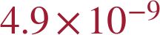

3. 0.0316
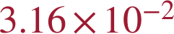

4. 0.0000000000529 meters (the radius of a hydrogen atom)
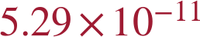 m
The 5 is in the eleventh decimal place.

For questions 5 and 6, write each number in standard form.
5. 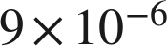
0.000009

6. 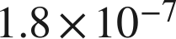
0.00000018

Powers of ten.
7. Write each value as a single power of 10, then as a fraction or decimal.
a. 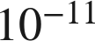, as a fraction

b. 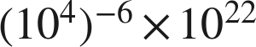
c. 


8. Two measurements are 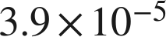 and 0.000000074.
a. Write in standard form.
0.000039
b. Write 0.000000074 in scientific notation.
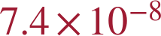
c. Which of the two is greater? Explain how you know.
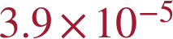 — the exponent −5 is greater than −8, so its power of 10 is larger; 0.000039 > 0.000000074.

9. Complete each comparison.
a. How many times larger is 9.6 than 3.2?
3
b. How many times larger is 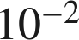 than 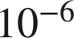?

−2 − (−6) = 4.
c. How many times larger is 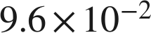 than 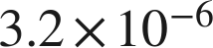?
3 × 10⁴ = 30,000 times larger

10. Write each value in scientific notation.
a. 988 ten-thousandths
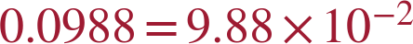
b. 0.00988
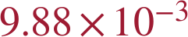
c. 988 millionths

11. Which is 0.00081 written in scientific notation?
○ A. 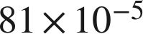
● B. 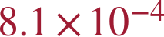
○ C. 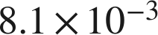
○ D. 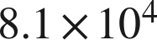
B

12. Select ALL of the expressions that are equal in value to 0.00052.
☒ A. 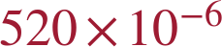
☒ B. 
☒ C. 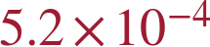
☐ D. 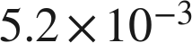
☒ E. 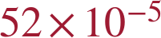
☐ F. 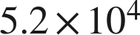
A, B, C and E
Only C is in scientific notation.

13. Light travels about 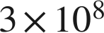 meters per second. A snail travels about 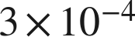 meters per second.
a. How many times faster is light? Write the answer as a power of 10 and in standard form.
 = 1,000,000,000,000 times
3 ÷ 3 = 1 and 8 − (−4) = 12.
b. How many times slower is the snail than light?
times slower — the same comparison read the other way.

